



Business Requirement Document
Finance
NWS House Connection System
DOCUMENT FOR

Table of Contents:
Table of Contents: 1
1. Introduction 3
1.1 Business Need 3
1.2 Expected Business Outcomes 3
1.3 Project Scope Summary 3
2. Business Requirement Details 4
2.1 Requirement Description 4
2.2 Functional Requirements 5
2.3 Non-Functional Requirements 5
3. System Integration 6
4. Process Flow 6
4.1 House Connection Supplier Master 6
4.2 House Connection Transaction 6
4.3 Process Flow 7
5. Application Prototype 8
6. Open and Close Issues 10
6.1 Open Issues 10
6.2 Closed Issues 10

Document Control

Date | Author | Version | Change Reference
19-Oct-2025 | Mr. Vignesh Subramani | 1.0 | No Previous Version
Change Record

Reviewers
Name | Position
Mr. Parthasarathy | Project Manager, 4iapps, Oman

Approver
Name | Position | Signature
Mr. Ibrahim Aziz Salim Al Amri | Accounts Payable Lead Accountant

Note to Holders:
If you receive an electronic copy of this document and print it out, please write your name on the equivalent of the cover page, for document control purposes.
If you receive a hard copy of this document, please write your name on the front cover, for document control purposes.

Introduction

1.1 Business Need
Nama Water Services currently operates the House Connection System in Custom OAF Page. House Connection System is used to capture the Supplier master and transaction details related to house connection supplier for delivering the water to customers.

1.2 Expected Business Outcomes
- Create Supplier Master details with Supplier details, Bank Details, Contract Details, Approver details and Supplier Attachments. Approval based on supplier master data and transactions for new records and for updates.

1.3 Project Scope Summary
The scope of this Application covers:
- Custom development of a Supplier Master and Transaction details.
- Approval workflow for the supplier master creation and updating.
- Transaction Creation and interfaced to Payables.
- Notification should be sent to payables team and ap distribution account should default based on Governate.

2. Business Requirement Details

2.1 Requirement Description
House Connection end users will create the supplier master data based on governate, wilayat. Each data will be stored in different Header information like Supplier Details, Bank Details, Contract Details, Supplier Attachment.
Supplier Details: Used to create supplier details for each governate, wilayat. Capturing the information related to suppliers.
Bank Details: Used to capture the bank information for the supplier. Attachment needs to be added.
Contract Details: Contract details like start date, end date, contract amount and other details captured.
Approver Region: For each region while creating data user has the option to capture the reviewer and approver details.
Once the House Connection supplier master is completed and approved. Users will create the transaction details. For each period based on the active supplier records the transaction will be created and once approved it will be interfaced to payables module.

2.2 Functional Requirements
Functional Requirement | Detailed Description
Supplier Details | Supplier information related to governate, wilayat, and other details. Approval will be required for each new and updating of suppliers.
Bank Details | Supplier bank details will be stored, and payment will be initiated with to the given bank account.
Contract Details | To maintain the contract details like start and end date, total contract amount.
Approvers Region | Choose the approver and reviewer based on the supplier governate region.
Supplier Attachments | Add attachment related to supplier details.

2.3 Non-Functional Requirements
- System should support 100% availability.
- Page load response time under 3 seconds.
- Complete audit trail for every action and system integration log.

3. System Integration
System | Module | Integration Point
Oracle Fusion | Accounts Payable | Automatic AP Invoice creation in Oracle Fusion upon successful approved transaction from house connection system.

4. Process Flow

4.1 House Connection Supplier Master
1. House Connection Supplier master entered by the house connection team end users.
2. Approver will review the master data and approve it.

4.2 House Connection Transaction
1. Transaction will be created based on the active supplier records from the house connection supplier master.
2. For each month transaction approval will be sent to House Connection Team Head.

4.3 Process Flow

5. Application Prototype
Supplier Master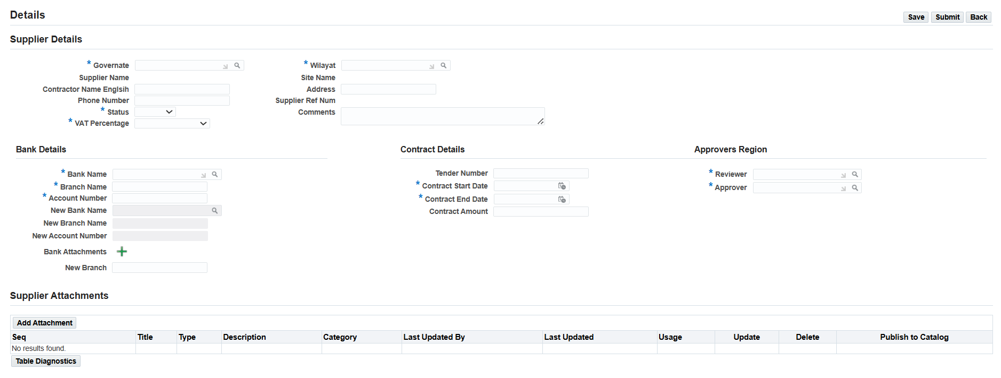

House Connection Transaction:
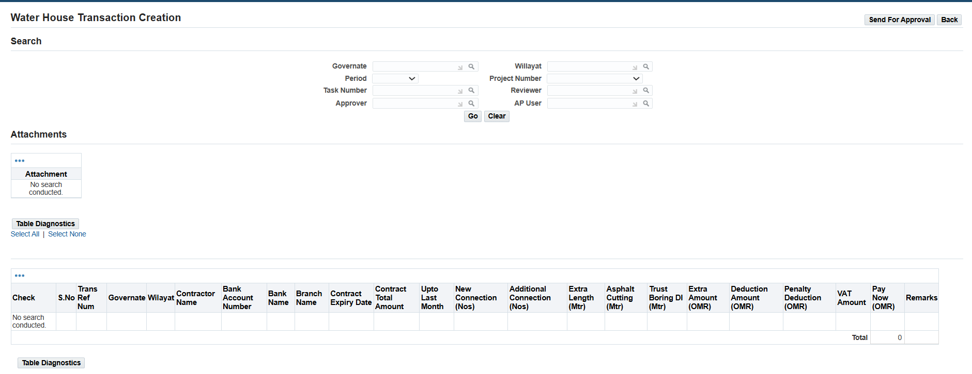

6. Open and Close Issues

6.1 Open Issues
S. No | Issue | Resolution | Responsibility | Target Date | Impact Date
1
2

6.2 Closed Issues
S. No | Issue | Resolution | Responsibility | Target Date | Impact Date
1
2

